Advanced Engineering Mathematics, by Erwin Kreyszig 10th. Ed.

**Problem Set 9.3**

No.1

(a)Let, and 



 (1)



 (2)





 (3)

From (1), (2) and (3) we know 

(b)

(α)



 (1)







 (2)

From (1) and (2) we know 

(β)



 (1)







 (2)

From (1) and (2) we know 

No.2

(i)or (ii)both andare parallel to 

No.3

Let, and 

(a)







(b) 





 (1)





 (2)

From (1) and (2) we know 

No.4

(12) Prove 



On the other hand



Thus 

No.5



The moment keeps the same magnitude but the direction of rotation axis is reversed.

No.6





If The rotation rate become double.

No.7

, 



y





x

z

No.8

, 

Velocity 



No. 9



 i.e.,  are on the same plane.

No. 10

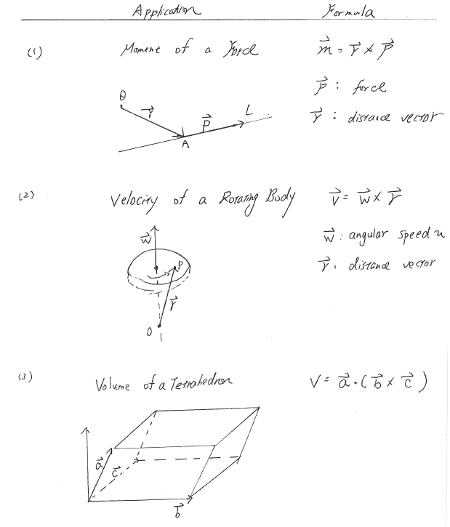

11-23

and 

No.11

(a)



(b)



(c)

No.12

(a)







(b)





(c)

(d)



No.13

(a)







(b)











No.14





















No.15









No.16

From prob. 13, 









No.17

(a) From prob. 16, 

  




(b) From prob. 16, 

  


No.18

(a) From prob. 11, 

  




(b) From prob. 11, 

  




No.19

(a)

(b)

No.20

(a)From prob. 1(a) 

From 16 





(b)

















No.21

(a)



 

(b)







(c)







No.22

(a)





















No.23

(a)







(b)











(c)

No. 24

(13) Prove 

Set   









 (1)

On the other hand 









 

  (2)

From (1) and (2) thus we prove 

(14) Prove 









 (1)







On the other hand









In



 

In





 



In









Therefore 



 (2)

Compare (1) and (2)  Q.E.D

(15) 





























(16) 



 (1)

 (2)

 (3)

From (1), (2) and (3) we know







No.25











No.26











No. 27

Four vertices 

P1

P2

P3

P4





Parallelogram area 

No.28

Set 

The vertices of the quadrangle are the midpoints of ,









 The quadrangleis a parallelogram.







The area is 

No. 29

Set









The area of the triangle is 

No. 30

  





The plane normal vector 





The plane is 

and  belongs to the plane.

 

 Or 

另解 Set the plane 

And  belong to the plane.







－  Or 

－  Since , 

From 

The plane equation is  Or 

No.31

Find the plane through (1, 3, 4), (1, -2, 6), (4, 0, 7)

Set 



The normal is 





The plane equation is

Substitute  into the above equation 

Therefore,  Or

另解 Set any point on the plane is 













 Or

No.32

Find the volume of the parallelepiped edged by the vectors

and 

The volume is the absolute value of 



The volume is 

No. 33

Set    















The volume of the tetrahedron is 

No. 34

Set    















The volume of the tetrahedron is 

No. 35

